LDPE REGRANULATE TRANSPERANT
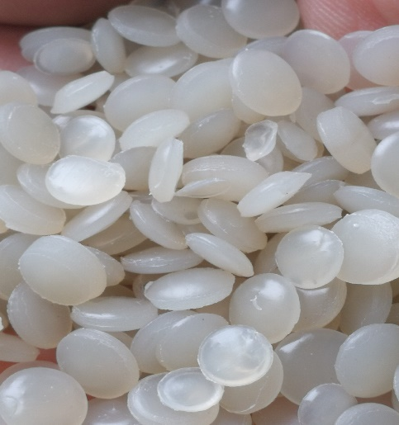
TYPE OF MATERIAL | LDPE
SHAPE | LANTILS
COLOUR | TRANSPERANT
PACKAGING | IN BIG BAGS 1100 kg
QUANTITY | 200 ton/month
PRICE | EXW Vilnius 670.00 EUR/t

TECHNICAL DATA
MFI | 0.810  190°C/2.16 kg
DENSITY | 0.959g/cm3
FILTRATION | 150µm
DATE OF ANALYSIS | 13 August, 2019

