INFORMATION ABOUT THE COMPANY

The company Logoplasta Ltd. is founded 8 years ago as a trading company. Last year the company took over the production of various plastics. The whole production was reorganized and modernized, so currently we are able to supply 300 tons of LDPE, HDPE granules monthly, according to specific requirements of individual customer. We also have all necessary licenses and permissions for the production.
Our production facilities are based in Vilnius’ industrial area and we have organized an efficient logistics to serve our customers. We are ready for a long-term cooperation and would like to invite you to see our production line any time convenient for you. For your reference we include few photos of our production below.

Sincerely yours,
Osvaldas Ciuksys
CEO
LOGOPLASTA LTD.

PHOTOS OF THE PRODUCTION FACILITIES:

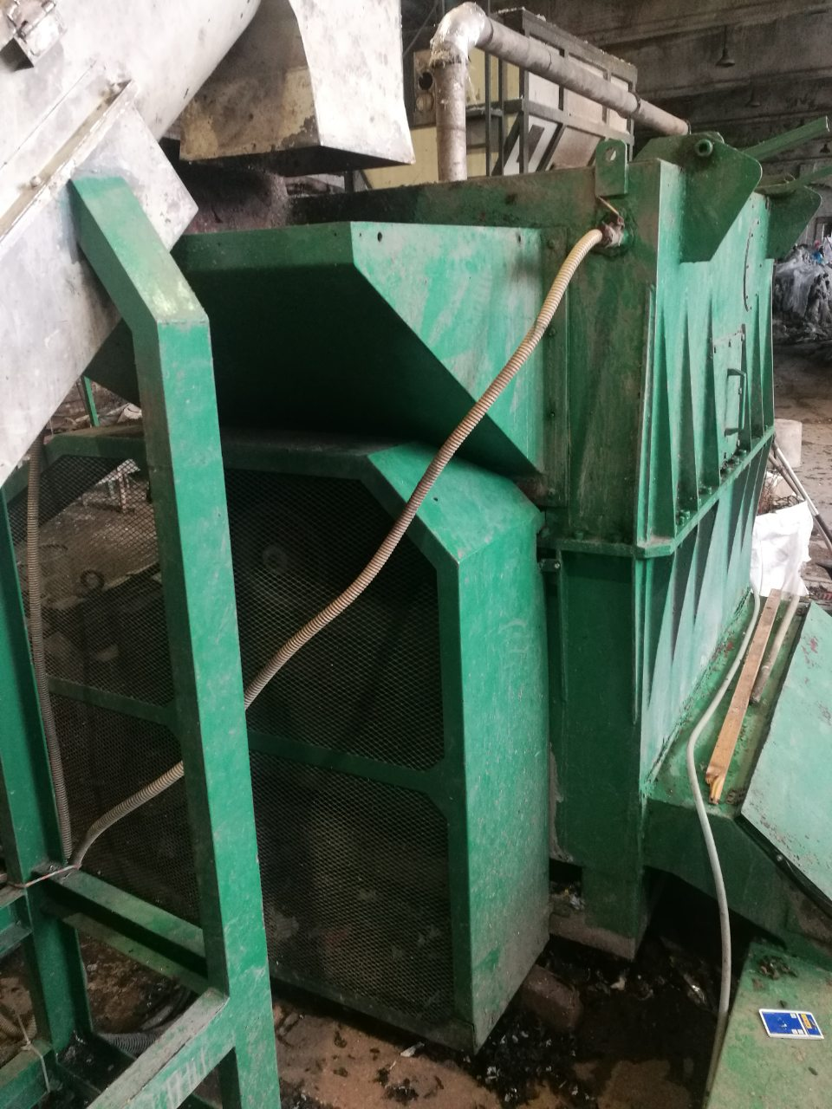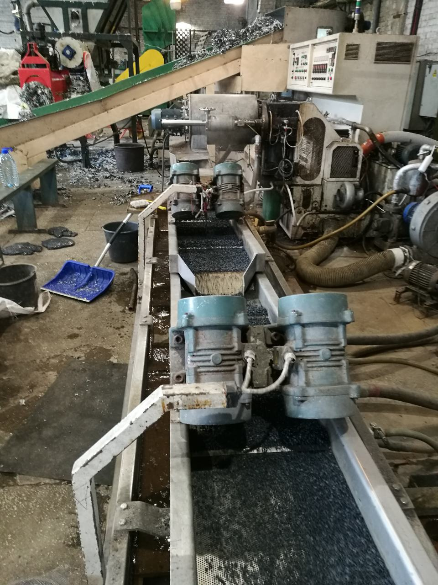
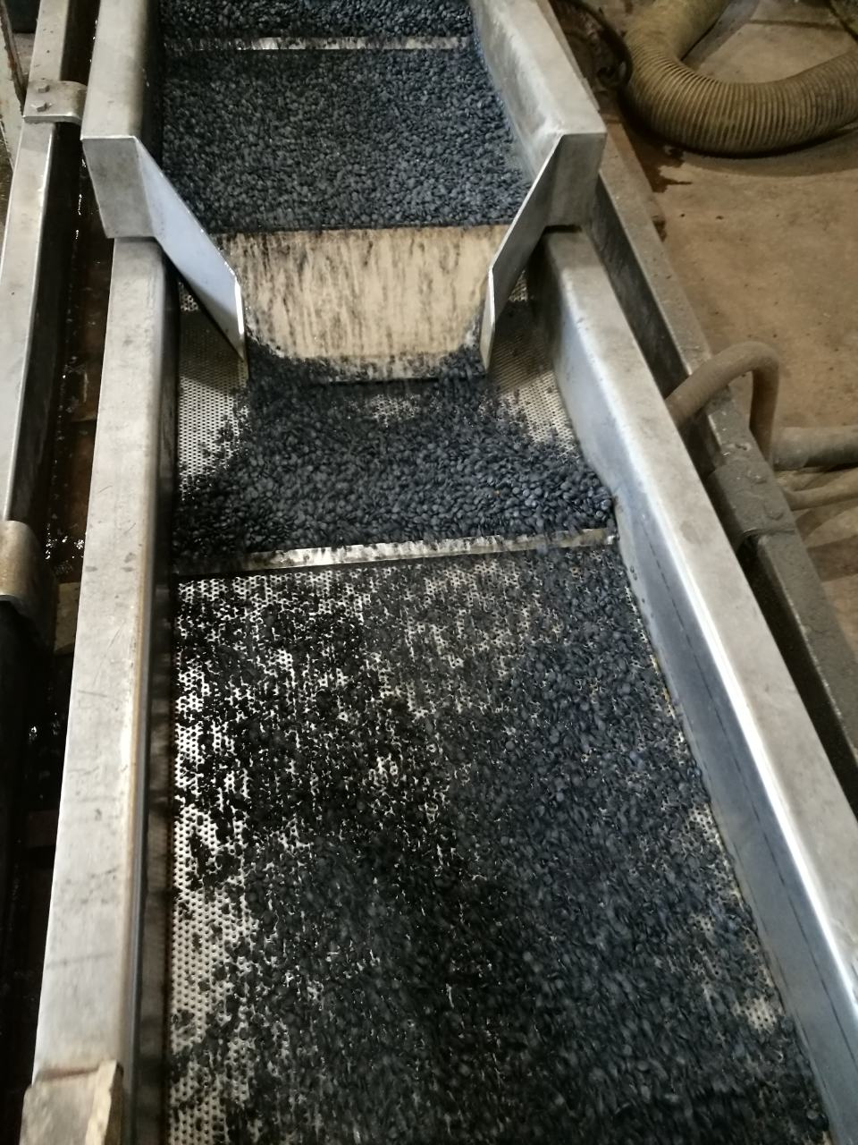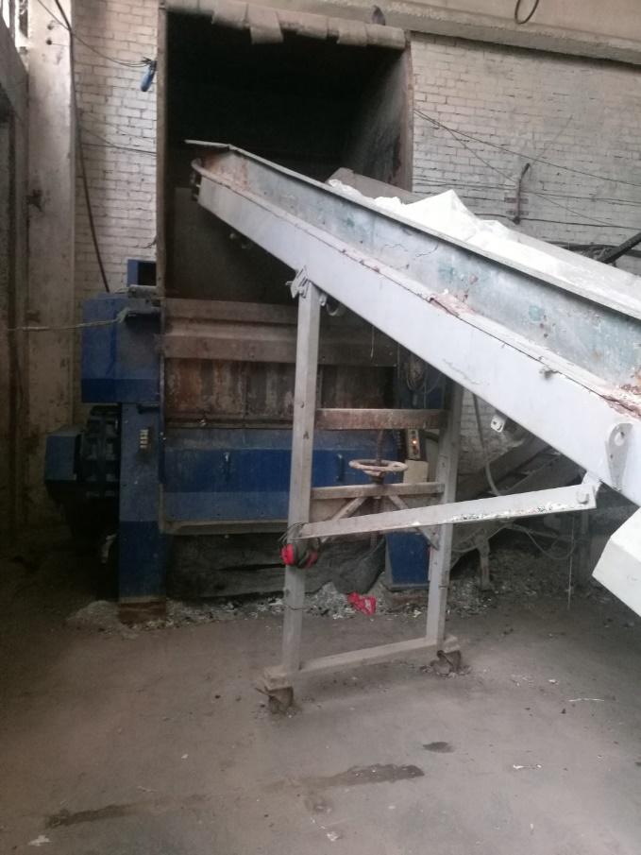

PHOTOS OF THE PRODUCTION FACILITIES:

