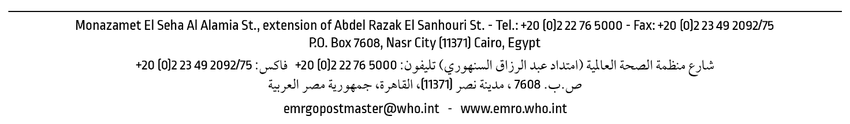
LSP.3/….
…. March 2020
Request for Expression of Interest
(EOI Number…..)

Objective of the EOI:
The purpose of this Expression of interest (EOI) is to have an updated and active roster for the prequalified suppliers to provide the World Health Organization (WHO) in (Country Name) with the below required category of supplies:
- ……….
- ………
Background:
The World Health Organization (WHO) in (Country Name) intends to prequalify the suppliers of the above-mentioned categories. This expression of interest (EOI) for pre-qualifications is launched to initiate an assessment of the technical and other capabilities of suppliers to be able to participate in future tenders.

Upon completion of the prequalification process, WHO will include the selected suppliers in a roster of prequalified suppliers. Only prequalified suppliers may directly be invited to submit bids or quotations in response to a formal solicitation, through a Request for Quotation (RFQ), or Invitation to Bid (ITB) at a later stage, with complete details of the requirements.

Submission requirements:
Suppliers are required to submit the following:
- Cover letter in supplier’s letterhead with company’s stamp and signature.
- the name of the company, its address, telephone and fax numbers, email address and details of contact person(s);
- the types of goods the supplier provides;
- number of continuous years in business;
- the countries in which the company has done business;
- a license or certificate of official registration or equivalent document to verify the company’s legal status;
- the name of owner(s) or CEO/managing director;
- any past experience with UN agencies (as an asset);
- any changes to the company name – suppliers are required to provide documentations and details of name changes;
- financial documents (audited or certified financial statements) for the last three years – this is applicable for suppliers likely to be awarded an order of USD 25 000 or above;
- supplier’s confirmation that the company has not been subject to any sanction or temporary suspension by the World Bank or any other international or UN organization;
- acceptance and signature of the attached UN Supplier Code of Conduct (Annex A); and the Self-Declaration Form (Annex B);
- details and email addresses of at least three independent, non-affiliated referees with whom the company has done business;
- for suppliers with which contracts above US$ 200 000 are likely to be issued, at least three recommendation letters are required from independent, non-affiliated clients/companies;
- quality standard certificates, for example ISO, CE or GMP (as an asset); and
- Submission of the attached completed excel sheet (Annex C).

Submission details:
The documentation must be submitted in a sealed envelope either in printed form or in CD/USB e-form. The envelope should be marked as EOI number……… and addressed to:
(write address…)
Expression of Interest no. EOI EMRO.3/2020/16

Tel.: ….; Fax: ……..
Email: (reference email)

Closing date:
Documents are required to be received by WHO maximum by: (dated: …..)

Queries:
Interested suppliers may obtain further information by contacting:
(write reference email address)

Eligibility criteria:
Suppliers will be disqualified if any of the below issues apply:
- if any of the requested mandatory information or documentation specific under the above “Submission requirements” has not been supplied to the satisfaction of WHO;
- if the supplier is currently suspended by WHO because:
- he has shown significant deficiencies in performing a prior WHO contract;
- WHO has been notified by an authoritative source that the supplier has been charged with committing fraud or a criminal offence in any country; or
- the supplier has undertaken any action that is serious and resulted in harm to WHO’s reputation or image.
Disclaimer:
This Request for Expression of Interest is not a solicitation, and replying to it does not guarantee that a vendor will be invited to any solicitation by WHO. No further details of the planned solicitation will be made available to vendors prior to the issuance of solicitation documents. In the event of a solicitation for the subject matter described herein, any bidding process and any subsequent purchase order or contract will be issued in accordance with WHO’s rules and procedures.
Any and all costs and expenses incurred in relation to, or ensuing from, the submission of an Expression of Interest will exclusively be borne by the applicant. The application and selection process set forth in this document will not be subject to claims for financial compensation of any kind whatsoever.
WHO is acting in good faith by issuing this Request for Expression of Interest, however, this Request for Expression of Interest does not entail any commitment on the part of WHO, either financial or otherwise. WHO reserves the right to send solicitation documents to vendors identified by WHO through means other than this Request for Expression of Interest; reject any or all Expression(s) of Interest, without incurring any obligation to inform the affected applicant(s) of that decision or the grounds thereof; and/or change or cancel the procurement process at any time, including during the Request for Expression of Interest or formal solicitation processes.

