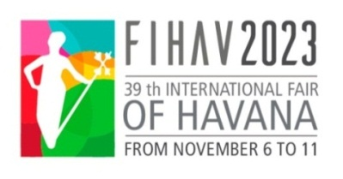

GENERAL INFORMATION
XXXIX INTERNATIONAL FAIR OF HAVANA - FIHAV 2023

DATE: November 6 to 11, 2023
OPENING HOURS: 10:00 – 17:00
VENUE: Expocuba fairground (Carretera del Rocío Km 3½, Arroyo Naranjo)

ORGANIZING COMMITTEE
- Ministry of Foreign Trade and Investment
- Chamber of Commerce of the Republic of Cuba
- PALCO Business Group

EXHIBITOR’S PROFILE: FIHAV is a multi-sector trade fair with raw materials, foodstuffs, textiles, consumer goods, machinery and equipment, technology and services as its main areas.
The participating enterprises are grouped by countries. Depending on the area required, they may have part of a pavilion, an entire pavilion or several pavilions.

GENERAL PROGRAM
October 25 to November 5  9:00 a.m. - 5:00 p.m. | Mounting of free design stands (accredited personnel with previous coordination with the Organizing Committee).
November 1 to 5  9:00 a.m. - 5:00 p.m. | Accreditation of exhibitors.  Mounting of modular stands.
Monday, November 6  10:00 am.  12:00 m. - 5:00 p.m. | Opening Ceremony. Plaza de las Banderas.  Professional visits.
Tuesday, November 7  10:00 a.m. - 5:00 p.m.  11:00 a.m. - 5:00 p.m. | Professional visits  VI Investment Forum.
Wednesday, November 8  10:00 a.m. - 5:00 p.m.  11:00 a.m. - 5:00 p.m. | Professional visits.  VI Investment Forum.
Thursday, November 9  10:00 a.m. - 5:00 p.m. | Professional visits.
Friday, November 10  10:00 a.m. - 5:00 p.m.  4:00 p.m. | Professional visits.  Awarding Ceremony. EXPOCUBA.
Saturday, November 11  9:00 a.m. – 5:00 p.m. | Admission of general public.
Monday, November 13  9:00 a.m. – 5:00 p.m. | Withdrawal of samples and dismounting of stands

The Expocuba fairground is Cuba’s largest exhibition center. It is located on the highway Carretera del Rocío, Km 3 ½, in the municipality of Arroyo Naranjo. It lies some 25 Km southeast of downtown Havana. It has an area of 600,000 m², 25,000 m² of net exhibition area and 25 pavilions for exhibitions.

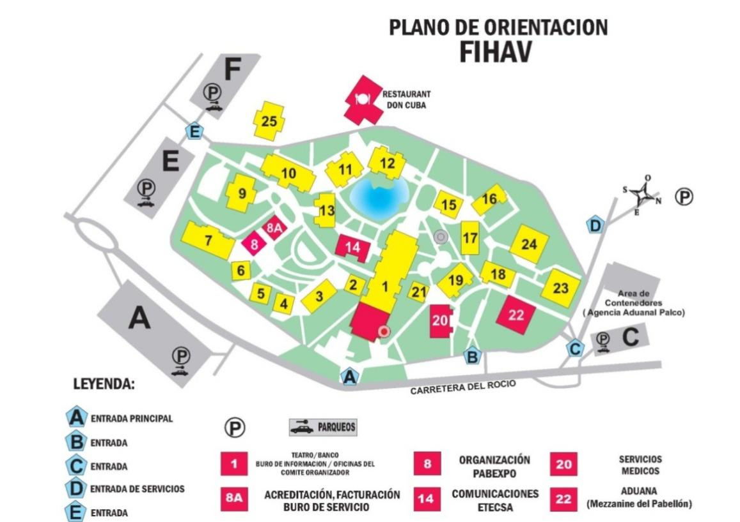

ENGAGEMENT OF EXHIBITION AREA:

The participation will be made official using the form Contract Request of Participation form, to be requested by addressing pabexpo1@palco.cu and rafaelalejandro@palco.cu or directly at Pabexpo with deadline October 7.

The form Contract Request of Participation will be delivered with the complete information, including the design of the stand, otherwise the Organizing Committee will not be responsible for the non-fulfillment of any of the requirements made by the applicant. It is indispensable that this Contract Request of Participation is approved and signed by the Fair Organizer.

To confirm your reservation and receive your location, the exhibitor must pay 50% of the cost of the area contracted at the time of formalizing the request. The deadline for payment of the remaining 50% of space and contracted services will be 20 days before the start of the Fair.

In the case that the samples to be exhibited in the Interior Area have large dimensions, weight or other special characteristics, the exhibitor must notify the Organizer not less than 20 days before the opening of the Fair, in order to obtain his or her evaluation and approval, in attention to the specifications of assembly, coordination for its access to the pavilions and requirements of the fairground.

All changes in the distribution of panels or any other element related to the assembly of the stands will be charged additionally, according to their complexity and proximity to the opening date of the Fair.
The Organizing Committee reserves the right when it deems it appropriate for the interests of a competition to make changes in the location of the stands and to communicate it to the exhibitor together with the proposal of the new location.

A 20% surcharge will be applied for all those services required once the Fair assembly begins and billing will be done at the Services Bureau located in Hall 8-A from November 1st.

WAIVER OR REDUCTION OF PARTICIPATION: The waivers or reductions of the original contracted space entail penalties, even when the space may be occupied for another exhibitor.
- Up to 30 days prior to the Fair - 50% of contracted space
- Up to 7 days or less prior the beginning of the Fair - 100% of contracted space.

TARIFFS:

- Indoor stand, mounted
Rate: CUP 3300.00/ sq.m (from 9 sq.m minimum to hire)
Includes: space, aluminum structure, white modular panels (2.42 x 0.95 m), carpet, sign with exhibitor’s name, power consumption up to 500W, cleaning, protection of samples, credentials (according to the rented area) and entry in the official catalogue (up to 15 lines).

- Indoor stand, mounted (Mezzanine)
Rate: CUP 3000.00/ sq.m (from 9 sq.m minimum to hire)
Includes: space, aluminum structure, white modular panels (2.42 x 0.95 m), carpet, sign with exhibitor’s name, power consumption up to 500W, cleaning, protection of samples, credentials (according to the rented area) and entry in the official catalogue (up to 15 lines).

- Indoor stand, not mounted (WITHOUT CARPET)
Rate: CUP 3100.00/ sq.m (from 9 sq.m minimum to hire)
Includes: space, power consumption up to 500W, cleaning, protection of samples, credentials (according to the rented area) and entry in the official catalogue (up to 15 lines)

- Indoor stand, not mounted (Mezzanine) (WITHOUT CARPET)
Rate: CUP 2880.00/ sq.m (from 9 sq.m minimum to hire)
Includes: space, power consumption up to 500W, cleaning, protection of samples, credentials (according to the rented area) and entry in the official catalogue (up to 15 lines)

- Indoor stand, not mounted (with Special Assembly) (WITHOUT CARPET)
Rate: CUP 5000.00/ sq.m (from 9 sq.m minimum to hire)
Includes: space, power consumption up to 500W, cleaning, protection of samples, credentials (according to the rented area) and entry in the official catalogue (up to 15 lines)

- Outdoor space
Rate: CUP 1900.00/ sq.m (from 9 sq.m minimum to hire)
Includes: space, power consumption up to 500W, cleaning, protection of samples, credentials (according to the rented area) and entry in the official catalogue (up to 15 lines)

HOW TO PAY:

Foreign exhibitors must make payment in EURO (established fair exchange rate)

- BANK TRANSFER OR CUP CHECK:
Pay to:
Account Holder: EES Empresa Organizadora de Congresos, Ferias y Exposiciones
Account Number: 0523220047250014
Swift Code: BMNBCUHXXX, Bank: Banco Metropolitano,
Bank Address: Sucursal 232
Calle 146 entre 11 y 17D, Reparto Siboney. Playa, La Habana, Cuba

- BANK TRANSFER OR CHECK:
Pay to:

Account Holder: Empresa Organizadora de Congresos, Ferias y Exposiciones – OCME
Account Number: 0300000006044236
Swift Code: BFICCUHH, Bank: Banco Financiero Internacional (BFI)
Bank Address: 5ta Ave esq. 92, Miramar, La Habana, Cuba

- CREDIT CARD:
(VISA International, MASTERCARD, CABAL, BFI, PREPAGO)
Credit Cards withdrawn from US Banks ARE NOT ACCEPTED
PREPAID CARD: Established and available to all foreigners who arrive in the country. These cards can be purchased at exchange branches (Cadecas) and/or at the airport upon arrival in the country. It can be purchased in any foreign currency accepted by the Central Bank of Cuba (US dollars are not accepted) and the exchange rate is applied by the Bank according to the currency in which it is purchased.

PROFESSIONAL VISITOR: Businessmen, entrepreneurs, buyers, professionals and interested in visiting the Fair can be accredited as professional visitors at a cost of 2 500.00 CUP. This accreditation includes: the right to visit the Fair every day, an official catalog, participation in official activities such as the opening and awards ceremonies and to establish commercial contacts.
They can register and pay directly with the Finance Department of PABEXPO or at the time of arriving at Expocuba Fairground. (Inquire in the point HOW TO PAY?)

REGISTRATION: The number of name badges per exhibiting firm is subject to the size of exhibition space requested as follows. The exhibitor can register additional personnel at a cost of $960.00 CUP each.
- 9 m² to 16 m²: 3 Name Badges
- 18 m² to 30 m²: 4 Name Badges
- 32 m² to 50 m²: 5 Name Badges
- 51 m² to 80 m²: 6 Name Badges
- 81 m² to 100 m²: 8 Name Badges
- More than 100 m²: 10 Name Badges

The name badge is for personal use only and not transferable to any other person. FIHAV authorities have the right to withdraw a name badge as a result of improper use; therefore if the exhibitor wants to remain in the Fair will have to pay $960.00 CUP for a new name badge.

MOUNTING RIGHTS: Companies and individual persons who work in the decoration and / or assembly must pay a fee of 1 200.00 CUP per credential and in the case of special assemblies 2 900.00 CUP. The credentials for the assembly and disassembly will only give access to the pavilion and the stand indicated and during these stages. The improper use of them entitles the authorities of the Fair to withdraw them and prohibit the entry of the persons involved.

The schedules and days of the assembly stage are those set by the Organizing Committee and when it is required, in an exceptional manner, they will be extended for the exhibitors' needs and the additional time will be invoiced in accordance with the established tariffs. At any time the request for additional time will be communicated to the Organizer with not less than 24 hours before the date you want to work out of the established time.

OFFICIAL CATALOGUE: The Fair publishes an official catalogue of its exhibitors that includes all the exhibiting companies in alphabetical order by country and by classification of the products that are exposed, as the case may be. The exhibitor has the right to include up to 15 lines of text in the products and / or services of his company. Attention should be paid to the information to be published, because the information used will be the one that comes exclusively from the data provided by the exhibitors, it must be delivered in digital or printed format and clearly drafted. The Organizing Committee is not responsible for errors or omissions and it will make the necessary arrangements in those cases that do not correspond with the form and style of the Catalogue.
Also the exhibitor will have the possibility of including advertising in this catalog, according to the established tariffs. The originals must be sent to the Organizer ready for printing (final art), in PDF format and dimensions of 16 x 22 cm.
The deadline to send information for the official catalog as well as for advertising is 24 days before the start of the Fair.

SAMPLES FOR EXHIBITION AT FIHAV: Agencia Transitaria PALCO is the official FIHAV forwarding and customs dispatch agency. All the information concerning arrival terms of goods, and documents required for customs dispatch may be obtained from:

- Agencia Transitaria Palco:
Address: Calle 180 esq.15 Rpto. Siboney, Playa, Apartado Postal 16046, La Habana, Cuba. Telephone: (53) 7271 3669
E-mail: lianetfernandez@palco.cu

AWARDS JURY: FIHAV has an award system

- Gold Medal of the National Office of Normalization for the Quality of the Product
- Award from the National Design Office for Product Design
- Communication Award of the Cuban Association of Social Communicators
- Special Awards from the Organizing Committee of FIHAV
The location of the judges is not known until at least 20 days before the start of the Fair.

VISAS: The exhibitors and participants of the Fair should travel to Cuba with a tourist visa acquired in their own countries consulate.

SERVICES TO EXHIBITORS AT EXPOCUBA: The Organizing Committee offers the following services to the exhibitors:

- Organization of a business round
- Trade information bureau
- Programs of conferences, seminars
- Mounting of stands
- Lettering and graphic design
- Power supply
- Customs dispatch, local transport and handling of samples
- Surveillance and security
- Meeting rooms
- Currency exchange (bank branch)
- Medical care
- Stand cleaning
- Parking

SOME PROHIBITIONS THAT THE EXHIBITOR MUST KNOW:

- Use of spaces out of the hired area for any purpose including advertising, frontages and outside or inside areas, through posters, advertising or any other printed mean except those previously arranged with the Fair organizer. In the case the permission is given it will be in base to the presented design and only once the tariff will be paid for that purpose.
- Use of equipment and/or the creation of conditions interfering with other exhibitors, live performance of music bands in the stand, common areas or in the halls of circulation, noisy demonstrations or advertising with loudspeakers or other means
- Loud volume of the emissions in the case of exhibitors presenting music hi-fi systems or other audio visual means, so that do not disturb the other participants.
- Hold tasting sessions, raffles or contests that might obstruct the circulation of visitors or might cause disturbances in the exhibition hall.
- Unauthorized use of name badges in any stage of the Fair.

- Access or parking of vehicles inside the exhibition halls.
- The disassembly and/or departure of samples and merchandise from the stands before the day and time of the end of the fair.
- The access of minors under 16 years of age to the venue in the stages of assembly, exhibition and disassembly, except the day that corresponds to the public visit.
- Smoking inside the pavilions of the enclosure.

MOST IMPORTANT DATES FOR THE EXHIBITOR:

Deadline October 6

- Presentation of the Contract Request of Participation form.
- Payment of 50 percent of the engaged space.
- Presentation of the free design stand project.

Deadline October 7

- Penalty of 50 % of the total area contracted for waiver or reduction in participation

Deadline October 13

  - Presentation of the Data for the Official Catalogue
  - Reception of the artwork for advertising in the Official Catalogue (PDF format, 16 x 22 cm).

Deadline October 16

- Payment of the remaining 50 percent of space and engaged services.
- Information on samples to exhibit of big dimensions, weight or other special characteristics.

Deadline October 29

- Penalty of 100 % of the total area contracted for waiver or reduction in participation

Deadline November 6

- Application for participation in the prizes to the quality of products, design and advertising.

