Technical specifications, quality and conditions for the quotation required
Steel Sheet Pile
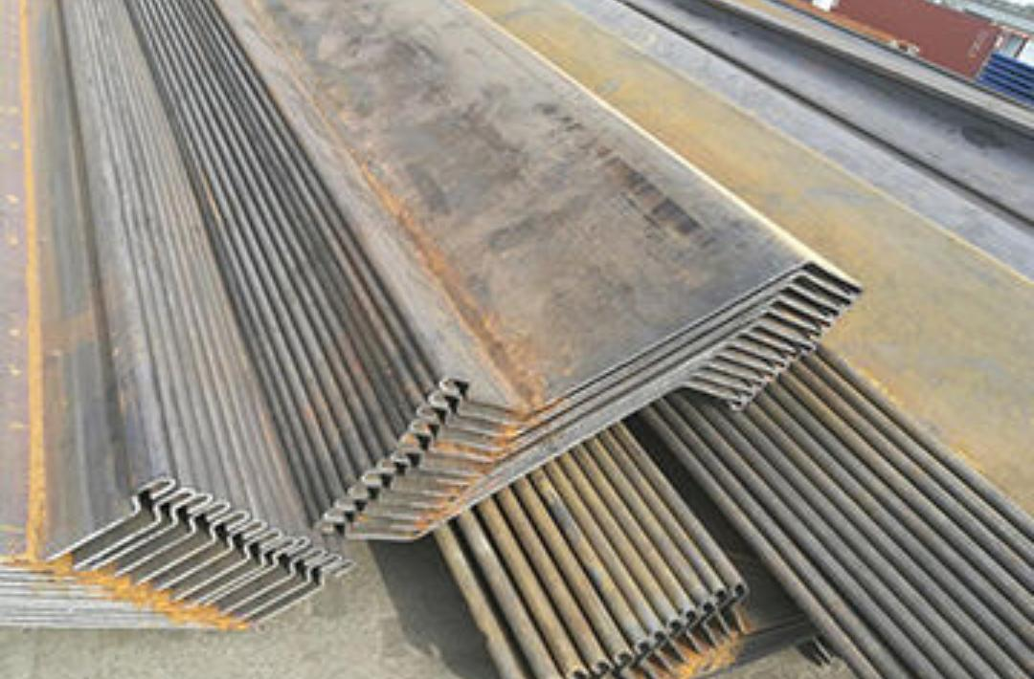
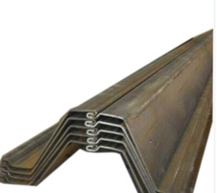

Width | Height | Thickness  t | Sectional area | Weight per pile | Weight per wall | Moment of Inertia | Modulus of Section
w | h
mm | mm | mm | cm²/m | kg/m | kg/m² | cm⁴/m | cm³/m
737 | 418 | 8 | 126,4 | 73,21 | 99,3 | 35877 | 1718
Specifications (Steel A 572, Grade 60, Z-shaped, which complies with the standard AASHTO M 202M or M 223M)

Amounts
2442 Parts of 11.6 meters long and 950 Parts of 13.5 meters long, (Total in tones 3012.75 TON)
Destination Port
Please quote to Caldera
Other applications
Send Quality Certification (This is mandatory)

